**SOFTWARE REQUIREMENT SPECIFICATION**

**DOCUMENT**

**LIBRARY MANAGEMENT SYSTEM**

**Version:** Version 2.0



**ABSTRACT**

This document is intended to be the SRS for develop **CACULATOR DESKTOP APP**



| **Project Title** | **LIBRARY MANAGEMENT SYSTEM** | | |
| --- | --- | --- | --- |
| **Lead Institution** | **THE INTERNATIONAL SCHOOL - DUY TAN UNIVERSITY** | | |
| **Project Mentor** | **Mr. Nguyen Dang Quang Huy** | | |
| **Team Name** | **Team 7** | | |
| **Team Members** | **Tran Quoc Minh** | | |
| **Doan Quoc Lap** | | |
| **Nguyen Hong Minh** | | |
| **Nguyen Ho Minh Tuan**  **Dinh Van Phuc** | | |
|  | | |
| **Start Date** | Jan 23,2024 | **End Date** | Jan 29,2024 |

**ROPRIETARY INFORMATION**: The information contained in this document is the property of **TEAM 7**. Except as specifically authorized in writing by **TEAM 7**, the holder of this document shall keep all information contained herein confidential and shall protect same in whole or in part from disclosure and dissemination to all third parties

**Table of Contents**

# Revision History

| **Date** | **Change Iterm** | **Description** | **by** | **Version** |
| --- | --- | --- | --- | --- |
| **24/1/2024** | Get requests from customers | After preparing the questions about the request and received the request from the customer | Tran Quoc Minh | Version 1.0 |
| **25/1/2024** | Start team meeting | Meet and refer to a number of training points, read through the training points and focus on project implementation, the team can fully understand the system requirements to create | All Members | Verison 1.0 |
| **23/1/2024** | Job analysis | Through specific requirements, analysis, clearly speaking, the leader needs to prepare in advance for the members. | Tran Quoc Minh | Verison 1.0 |
| **23/1/2024** | Share the work | Get BFD, contextual diagram, DFD level 1, DFD level 2,  The mandatory rules of the project | Doan Quoc Lap | Verision 1.0 |
| **24/1/2024** | Mr. Huy corrected | Fix BFD, DFD, USE CASE, font size, font pattern, context diagram, more clearly about the missing and suggest some important things | Doan Quoc Lap,  Dinh Van Phuc,  Tran Quoc Minh | Verision 1.0 |
| **25/1/2024** | Editing group | BFD, DFD, USE CASE, Context Diagram, font size, font | Doan Quoc Lap,  Dinh Van Phuc,  Tran Quoc Minh | Verision 1.0 |
| **26/1/2024** | Complete DFD, System Context Diagram | DFD 1 and 2, System Context Diagram | Doan Quoc Lap,  Dinh Van Phuc,  Tran Quoc Minh | Verision 2.0 |
|  |  |  |  |  |

# Introduction

## Purpose

This documentation describes a Caculator system including all needed information and feature materials in detail for implementation. The purposes of this document are as below:

* To supports the project manager having an overview of the system as well as doing project estimation
* To describes the architectural drivers and use cases in details. Based on this document, architect analyst and designer will be able to implement the system easily.
* To supports tester (QC) writing acceptance test and test plan.

## Intended Audience and Reading Suggestions

| Intended Audience | Reading Suggestions |
| --- | --- |
| Project manager | High level functional requirement, business constraints for estimation |
| Architect analyst and designer | Overall description and user cases to architect and design the system |
| Quality control | Overall description and user cases to make test plan and write acceptance test |
|  |  |

## References

# Project Overview

## Project Description

## Information Technology has revolutionized the life of human beings and has made lives easier by the various kinds of applications. In the light of the rapid changes with the use of Information Technology, there are many tools,technologies and systems that have been produced and invented.

## This project is concerned with developing a Caculator more efficient and easy to handle. The Caculator system enables a optional service. The goals of this project are to provide simplicity solutions for desktop option

## Business Need

This system had a number of advantages:

- Support Student, Accountant solving all matches

## Project Analyst

### Business Function Diagram

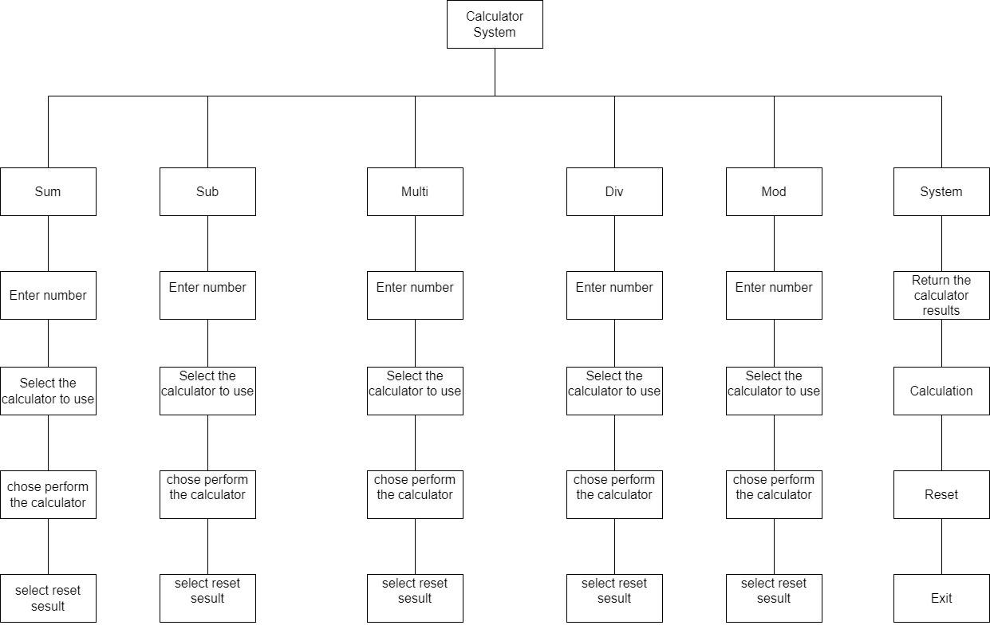

### System Context Diagram

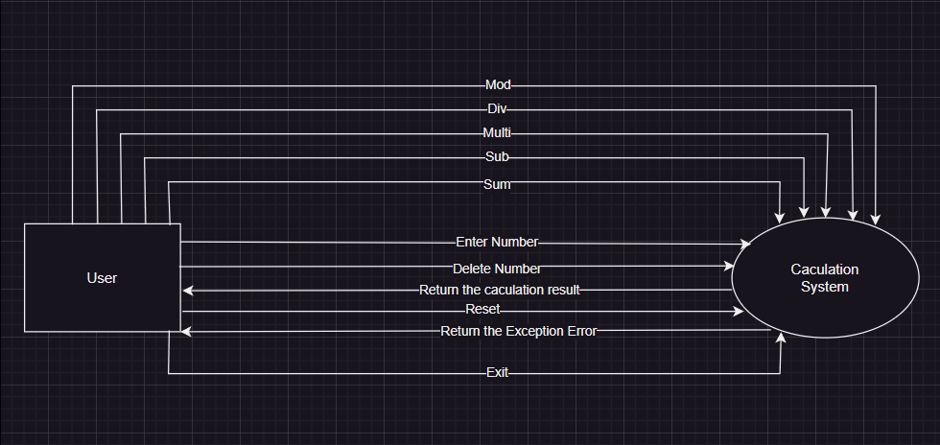

## Software Requirement Specification

### High level Functional Requirement (FR)

| FR1.1 | **Title** | **Main user interface** |
| --- | --- | --- |
| All Actor | The actor uses this Use Case to access the system. |
| Description | The system displays the main interface, the user enters numbers, the system checks and displays the result of calculation. |
| FR1.2 | **Title** | **Mathematical calculations** |
| User | This use case enables users to use mathematical calculations |
| Description | The use case begins when a user wishes to do a calculation. Users import the number into the system, then choose the mathematical calculations function example: addition, subtraction, multiplication, division, and modulo to do this action. |
| FR1.3 | **Title** | **Display the result** |
| System | This use case allows system to display the result to readers |
| Description | The system shows the result which users want to see after they input the calculation. |

### Stakeholders

| **Stakeholder** | **Description** |
| --- | --- |
| Users (Student,) | System users |
|  |  |

### Use case

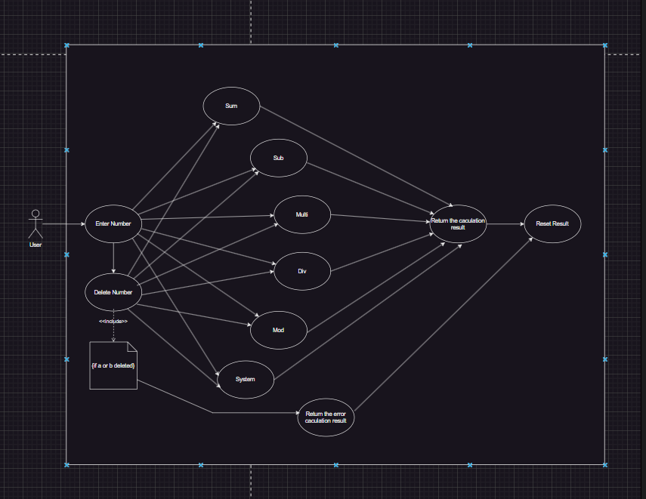

### List of use case

| Use case ID | Use case name | Functional Req |
| --- | --- | --- |
| UC.01 | Sum | FR.1 |
| UC.02 | Sub | FR.2 |
| UC.03 | Multi | FR.3 |
| UC.04 | Div | FR.4 |
| UC.05 | Mod | FR.5 |

**2.4.5.Use Case Specification**

##### UC 01: Interact with button

1. Use Case Diagram   
     
     
     
     
     
     
     
   
2. Use Case Specification

| Use case ID | **UC.01** | | | | |
| --- | --- | --- | --- | --- | --- |
| Use case name | Sum calculation | | | | |
| Create by | Doan Quoc Lap | | Last updated by | | Doan Quoc Lap |
| Date created | January 22,2024 | | Date last updated | | January 27, 2024 |
| Actor | User | | | | |
| Description | Helps users perform sum calculations | | | | |
| Trigger | Click on sum perform the calculation | | | | |
| Pre-condition | Performed the calculation successfully | | | | |
| Post-condition | If the calculation is successful, the user can view the results and reset the results to perform the next calculation | | | | |
| Main Success Scenario: | **Step** | **Actor Action** | | **System Response** | |
| 1 | The user accesses the calculation sheet | | The system displays the calculation sheet interface | |
| 2 | The user enters the data to be calculated | | The system displays the data to be calculated | |
| 3 | The user chooses the sum calculation to perform | | he system displays the selected sum calculation on the spreadsheet | |
| 4 | The user chooses to perform the calculation | | The system displays the results of the sum calculation just performed | |
| 5 | The user chooses to reset the results | | The display system has reset the results | |
| 6 | The user chooses to exit the calculation table | | The display system has left the calculation sheet | |
| Alternative Scenario | **Step** | **Actor Action** | | **System Response** | |
| 2 |  | | If the system displays the input as a letter | |
| 2 | User re-enters | | Return to step 1 | |
| Priority | High | | | | |
| Business rule | N/A | | | | |

| Use case ID | **UC.02** | | | | |
| --- | --- | --- | --- | --- | --- |
| Use case name | Sub calculation | | | | |
| Create by | Doan Quoc Lap | | Last updated by | | Doan Quoc Lap |
| Date created | January 22,2024 | | Date last updated | | Januari 27, 2024 |
| Actor | User | | | | |
| Description | Helps users perform sub calculations | | | | |
| Trigger | Click on sub and perform the calculation | | | | |
| Pre-condition | Performed the calculation successfully | | | | |
| Post-condition | If the calculation is successful, the user can view the results and reset the results to perform the next calculation | | | | |
| Main Success Scenario: | **Step** | **Actor Action** | | **System Response** | |
| 1 | The user accesses the calculation sheet | | The system displays the calculation sheet interface | |
| 2 | The user enters the data to be calculated | | The system displays the data to be calculated | |
| 3 | The user chooses the sub calculation to perform | | he system displays the selected sub calculation on the spreadsheet | |
| 4 | The user chooses to perform the calculation | | The system displays the results of the sub calculation just performed | |
| 5 | The user chooses to reset the results | | The display system has reset the results | |
| 6 | The user chooses to exit the calculation table | | The display system has left the calculation sheet | |
| Alternative Scenario | **Step** | **Actor Action** | | **System Response** | |
| 2 |  | | If the system displays the input as a letter | |
| 2 | User re-enters | | Return to step 1 | |
| Priority | High | | | | |
| Business rule | N/A | | | | |

| Use case ID | **UC.03** | | | | |
| --- | --- | --- | --- | --- | --- |
| Use case name | Multiplication function | | | | |
| Create by | Doan Quoc Lap | | Last updated by | | Doan Quoc Lap |
| Date created | Januari 22,2024 | | Date last updated | | Januari 27, 2024 |
| Actor | User | | | | |
| Description | Helps users perform multiplication calculations | | | | |
| Trigger | Click on multiplication and perform the calculation | | | | |
| Pre-condition | Performed the calculation successfully | | | | |
| Post-condition | If the calculation is successful, the user can view the results and reset the results to perform the next calculation | | | | |
| Main Success Scenario: | **Step** | **Actor Action** | | **System Response** | |
| 1 | The user accesses the calculation sheet | | The system displays the calculation sheet interface | |
| 2 | The user enters the data to be calculated | | The system displays the data to be calculated | |
| 3 | The user chooses the multiplication calculation to perform | | The system displays the selected multiplication calculation on the spreadsheet | |
| 4 | The user chooses to perform the calculation | | The system displays the results of the multiplication calculation just performed | |
| 5 | The user chooses to reset the results | | The display system has reset the results | |
| 6 | The user chooses to exit the calculation table | | The display system has left the calculation sheet | |
| Alternative Scenario | **Step** | **Actor Action** | | **System Response** | |
| 2 |  | | If the system displays the input as a letter | |
| 2 | User re-enters | | Return to step 1 | |
| Priority | High | | | | |
| Business rule | N/A | | | | |

| Use case ID | **UC.04** | | | | |
| --- | --- | --- | --- | --- | --- |
| Use case name | Div calculation | | | | |
| Create by | Doan Quoc Lap | | Last updated by | | Doan Quoc Lap |
| Date created | Januari 22,2024 | | Date last updated | | Januari 27, 2024 |
| Actor | User | | | | |
| Description | Helps users perform div calculations | | | | |
| Trigger | Click on div and perform the calculation | | | | |
| Pre-condition | Performed the calculation successfully | | | | |
| Post-condition | If the calculation is successful, the user can view the results and reset the results to perform the next calculation | | | | |
| Main Success Scenario: | **Step** | **Actor Action** | | **System Response** | |
| 1 | The user accesses the calculation sheet | | The system displays the calculation sheet interface | |
| 2 | The user enters the data to be calculated | | The system displays the data to be calculated | |
| 3 | The user chooses the div calculation to perform | | he system displays the selected div calculation on the spreadsheet | |
| 4 | The user chooses to perform the calculation | | The system displays the results of the div calculation just performed | |
| 5 | The user chooses to reset the results | | The display system has reset the results | |
| 6 | The user chooses to exit the calculation table | | The display system has left the calculation sheet | |
| Alternative Scenario | **Step** | **Actor Action** | | **System Response** | |
| 2 |  | | If the system displays the input as a letter | |
| 2 | User re-enters | | Return to step 1 | |
| Priority | High | | | | |
| Business rule | N/A | | | | |

| Use case ID | **UC.05** | | | | |
| --- | --- | --- | --- | --- | --- |
| Use case name | Multiplication function | | | | |
| Create by | Doan Quoc Lap | | Last updated by | | Doan Quoc Lap |
| Date created | Januari 22,2024 | | Date last updated | | Januari 27, 2024 |
| Actor | User | | | | |
| Description | Helps users perform mod calculations | | | | |
| Trigger | Click on mod and perform the calculation | | | | |
| Pre-condition | Performed the calculation successfully | | | | |
| Post-condition | If the calculation is successful, the user can view the results and reset the results to perform the next calculation | | | | |
| Main Success Scenario: | **Step** | **Actor Action** | | **System Response** | |
| 1 | The user accesses the calculation sheet | | The system displays the calculation sheet interface | |
| 2 | The user enters the data to be calculated | | The system displays the data to be calculated | |
| 3 | The user chooses the mod calculation to perform | | he system displays the selected mod calculation on the spreadsheet | |
| 4 | The user chooses to perform the calculation | | The system displays the results of the mod calculation just performed | |
| 5 | The user chooses to reset the results | | The display system has reset the results | |
| 6 | The user chooses to exit the calculation table | | The display system has left the calculation sheet | |
| Alternative Scenario | **Step** | **Actor Action** | | **System Response** | |
| 2 |  | | If the system displays the input as a letter | |
| 2 | User re-enters | | Return to step 1 | |
| Priority | High | | | | |
| Business rule | N/A | | | | |

## 2.4.6 . Activity Diagrams

## Caculator System

# Appendix A: Glossary

| FR | Functional Requirement |
| --- | --- |
| QA | Quality Attribute |
| UC | Use case |
| BR | Business rule |